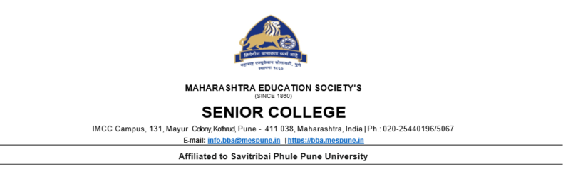

**Synopsis**

**Project Title: The Fashion Find**

**Submitted by: Yashraj Renke 2230034**

**Objective:**

**Online sales of clothes and apparel. Ensure the website is optimized for various devices and screen sizes, providing a seamless user experience across desktops, tablets, and mobile devices. Implement robust security measures to ensure the safety of customer data and facilitate secure transactions for online purchases.**

**Introduction:**

**Welcome to The Fashion Find, your ultimate destination for all things Fashion! Immerse yourself in a world of captivating fashion, clothing and apparel curated just for you.**

**Discover a Universe of Possibilities: Step into a realm where imagination knows no bounds. Whether you're a seasoned otaku or just starting your anime journey, our store is a treasure trove of handpicked clothing merchandise, ranging from the latest releases to timeless classics.**



**Shop with Confidence: At The Fashion Find, your satisfaction and security are our top priorities. Our user-friendly interface and secure payment gateways make shopping a breeze. Rest easy knowing that your personal information is handled with the utmost care, ensuring a safe and enjoyable shopping experience.**

**Exclusive Deals and Promotions: Indulge in your passion without breaking the bank! Take advantage of our exclusive deals, promotions, and discounts that make collecting even more rewarding. Be on the lookout for limited-time offers and special bundles that add extra value to your purchases.**

**Technology Used:**

1. **HTML**
2. **CSS**
3. **JavaScript**



**Modules:**

**1. Login Module:**

**- User Registration: Allow users to create accounts by providing necessary information.**

**- Login/Logout: Provide a secure login system with options for users to log in and log out.**

**- User Profiles: Enable users to manage their profiles, update personal information, and track order history.**

**- Password Recovery: Implement a secure process for users to recover their passwords if forgotten.**

**2. Contact Us Module:**

**- Contact Form: Include a user-friendly contact form for general inquiries and support.**

**- Customer Support Information: Display contact details, including email addresses and phone numbers, for customer support.**

**- Physical Address: Provide the physical location of the store (if applicable) for customers who prefer in-person assistance.**

**3. Feedback Module:**

**- Customer Reviews: Allow users to leave reviews and ratings for products they have purchased.**

**- Feedback Form: Implement a feedback form for users to share their thoughts, suggestions, and concerns.**

**- Moderation: Admin tools for moderating and responding to user feedback to maintain a positive community.**



**4. Products Module:**

**- Product Listings: Display a comprehensive catalog of anime products, organized by categories and genres.**

**- Product Details: Include detailed information about each product, including images, descriptions, specifications, and prices.**

**- Search and Filter: Implement search functionality and filters to help users easily find specific products.**

**- Inventory Management :Admin tools for managing product availability, restocking, and updating product information.**